Infant Supply List

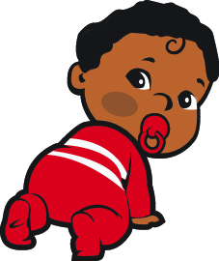

☐Prepared bottles
☐Pacifiers
☐Baby food and cereal when age appropriate
☐Diapers
☐Wipes
☐Diaper ointment
☐Extra Clothes
☐Extra formula (for emergency use only)
☐Diaper bag (large enough to store empty bottles and
clothes that may be sent home)

Please Remember:

- Please label all items with child’s first and last name.

- All creams and sunscreens to be applied require a completed medical authorization form and must be kept in their original containers with your child’s full name on it.

- All prescriptions must be in the original containers with the patient’s name, dosage and prescribed time to be given. The doctor must complete a medical form before medication can be administered.

- Any over the counter medications (Tylenol, Motrin, etc.) require a permission form from your doctor which must include the proper dosage for your child’s weight, age and the reason why it is to be administered. All medications must be in it’s original packaging.

