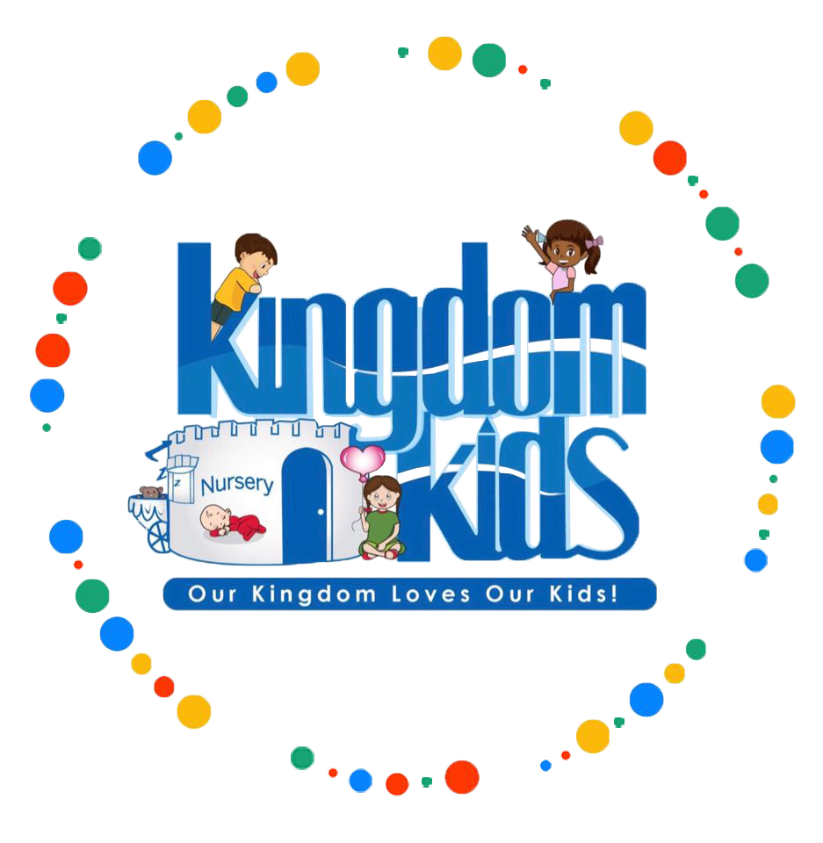June |  |  |  |  |  | July 2021  S M T W T F S  1 2 3  4 5 6 7 8 9 10  11 12 13 14 15 16 17  18 19 20 21 22 23 24  25 26 27 28 29 30 31
SUNDAY |  | MONDAY | TUESDAY | WEDNESDAY | THURSDAY | FRIDAY | SATURDAY
 |  | Ushers Ferry  11a-2:30p | CR Public  Library Program  9:30a-11:30a | Splash / Picnic  10:30a-12p | CR Public  Library Program  9:30a-11:30a | Splash Pad  10:30-11:30p
 |  | Splash Pad  10:30-11:30p | CR Public  Library Program  9:30a-11:30a | Splash / Picnic  10:30a-12p | CR Public  Library Program  9:30a-11:30a | Movies  9a-12p
 |  | Squaw Creek  Hiking/Trail/Picnic  10a-12p | CR Public  Library Program  9:30a-11:30a | Splash / Picnic  10:30a-12p | CR Public  Library Program  9:30a-11:30a | Splash Pad  10:30-11:30p
 |  | Splash Pad  10:30-11:30p | CR Public  Library Program  9:30a-11:30a | Splash / Picnic  10:30a-12p | CR Public  Library Program  9:30a-11:30a | CR Bowl 12:45p-2:30p

July |  |  |  |  |  | August 2021  S M T W T F S  1 2 3 4 5 6 7  8 9 10 11 12 13 14  15 16 17 18 19 20 21  22 23 24 25 26 27 28  29 30 31
SUNDAY |  | MONDAY | TUESDAY | WEDNESDAY | THURSDAY | FRIDAY | SATURDAY
 |  | Splash Pad  10:30-11:30p | CR Public  Library Program  9:30a-11:30a | Splash / Picnic  10:30-12p | CR Public  Library Program  9:30a-11:30a | Movies  9a-12p
 |  | Old McDonald Farm  9:30a-12 | CR Public  Library Program  9:30a-11:30a | Splash / Picnic  10:30-12p | CR Public  Library Program  9:30a-11:30a | Splash Pad  10:30-11:30p
 |  | Splash Pad  10:30-11:30p | CR Public  Library Program  9:30a-11:30a | Splash / Picnic  10:30-12p | CR Public  Library Program  9:30a-11:30a | Indian Creek Nature Center  TBA
 |  | AirFX  TBA | CR Public  Library Program  9:30a-11:30a | Splash / Picnic  10:30-12p | CR Public  Library Program  9:30a-11:30a | Splash Pad  10:30-11:30p

August |  |  |  |  |  | September 2021  S M T W T F S  1 2 3 4  5 6 7 8 9 10 11  12 13 14 15 16 17 18  19 20 21 22 23 24 25  26 27 28 29 30
SUNDAY |  | MONDAY | TUESDAY | WEDNESDAY | THURSDAY | FRIDAY | SATURDAY
 |  | Children’s  Museum  9:15a-12p | CR Public  Library Program  9:30a-11:30a | Splash / Picnic  10:30-12p | CR Public  Library Program  9:30a-11:30a | Splash Pad  10:30-11:30p
 |  | Splash Pad  10:30-11:30p | CR Public  Library Program  9:30a-11:30a | Splash / Picnic  10:30-12p | CR Public  Library Program  9:30a-11:30a | Movies  9a-12p
 |  | Play Station  9:30a-11:30a | CR Public  Library Program  9:30a-11:30a | Splash / Picnic  10:30-12p | CR Public  Library Program  9:30a-11:30a | Splash Pad  10:30-11:30p
 |  | Splash Pad  10:30-11:30p | CR Public  Library Program  9:30a-11:30a | Splash / Picnic  10:30-12p | CR Public  Library Program  9:30a-11:30a | Summer Program Ends | Kingdom  Carnival  12p-3p

