Child(ren) Supply List
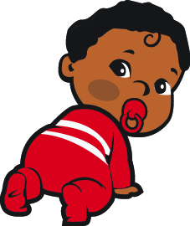

☐Pacifiers
☐Diapers
☐Pull Ups
☐Wipes
☐Diaper ointment
☐Extra Clothes (At least 2 sets, 3 if potty training)
☐Extra formula (If necessary)

Please Remember:

- Please label all items with child’s first and last name.

- All creams and sunscreens to be applied require a completed medical authorization form and must be kept in their original containers with your child’s full name on it.

- All prescriptions must be in the original containers with the patient’s name, dosage and prescribed time to be given. The doctor must complete a medical form before medication can be administered.

- Any over the counter medications (Tylenol, Motrin, etc.) require a permission form from your doctor which must include the proper dosage for your child’s weight, age, and the reason why it is to be administered. All medications must be in its original packaging.

